Requirements Specification

Company 10

Martin Ruzicka

Version 0.5

# Status

|  |  |  |
| --- | --- | --- |
| Reviewed | Martin Ruzicka, Hans Sanell, Jonas Mattsson, Henrik Nilsson, Vamsi Seshabhattaru | 2010-02-03 |
| Approved | Sebastian Rehnby (PM) | 2010-02-07 |

# Project identity

Company 10, 2010

Chalmers University of Technology, MPSEN

|  |  |  |  |
| --- | --- | --- | --- |
| **Name** | **Responsibility** | **Phone** | **E-mail** |
| Martin Ruzicka | Software Architect | 070 219 20 81 | [ruzicka@student.chalmers.se](mailto:ruzicka@student.chalmers.se) |
| Jonas Mattsson | Database Designer | 070 58 18 095 | [emattsso@student.chalmers.se](mailto:emattsso@student.chalmers.se) |
| Hans Sanell | Software Architect | 073 53 55 210 | [hansn@student.chalmers.se](mailto:hansn@student.chalmers.se) |
| Sebastian Rehnby | Project Manager | 0735 080 850 |  |
| Vamsi Seshabhattaru | Quality Manager | 0739 190 703 | [vamsi@student.chalmers.se](mailto:vamsi@student.chalmers.se) |
| Henrik Schulze Nilsson | Graphical Designer | 0733 643 501 | [henrnil@student.chalmers.se](mailto:henrnil@student.chalmers.se) |

[suit-group-10@googlegroups.com](mailto:suit-group-10@googlegroups.com)

**Client:** Central Operative & Independent Retailers Acquirer, 9 Downing St, Westminster, London SW1A, UK

**Client Contact:** Peter Arch, +44 333 757589, [peter.arch@coira.com](mailto:peter.arch@coira.com)

**Supervisor:** Per Zaring

# Content

1. Introduction 5

1.1. Stakeholders 5

1.2. Aim and goal 5

1.3. Use cases 5

1.4. Background information 5

1.5. Definitions 6

2. Overview of the system 6

2.1. Product components 6

2.2. Dependencies with other systems 6

2.3. Included sub-systems 7

2.4. Delimitations 7

2.5. Design philosophy 7

2.6. General requirements of the whole system 7

2.6.1. Design requirements 7

2.6.2. Functional requirements 8

3. Sub-system 1 – MUW 8

3.1. Description of MUW 8

3.2. Interface requirements 9

3.3. Design requirements 9

3.4. Functional requirements 9

4. Sub-system 1 – PUW 10

4.1. Description of PUW 10

4.2. Interface requirements 11

4.3. Design requirements 11

4.4. Functional requirements 11

5. Sub-system 3 – LUW 11

5.1. Description of LUW 11

5.2. Interface requirements 12

5.3. Design requirements 13

5.4. Functional requirements 13

6. Performance requirements 13

7. Extensibility 13

8. Reliability 14

9. Economy 14

10. Security 14

11. Delivery requirements 14

12. Documentation 14

13. Education 14

14. Quality requirements 15

15. Maintainability 15

# Document History

|  |  |  |  |  |
| --- | --- | --- | --- | --- |
| **Version** | **Date** | **Changes** | **Responsible** | **Approved** |
| 0.5 | 2010-02-03 | Layout fixing. | MR | SR |
| 0.4 | 2010-02-05 | Writing, prioritizing requirements. | MR | SR |
| 0.3 | 2010-02-03 | Change in template | MR | SR |
| 0.2 | 2010-02-02 | Updated text and added images | MR, JM, HS | SR |
| 0.1 | 2010-02-01 | Created template. | MR | SR |

Introduction

This document describes the software requirements for the UW system.

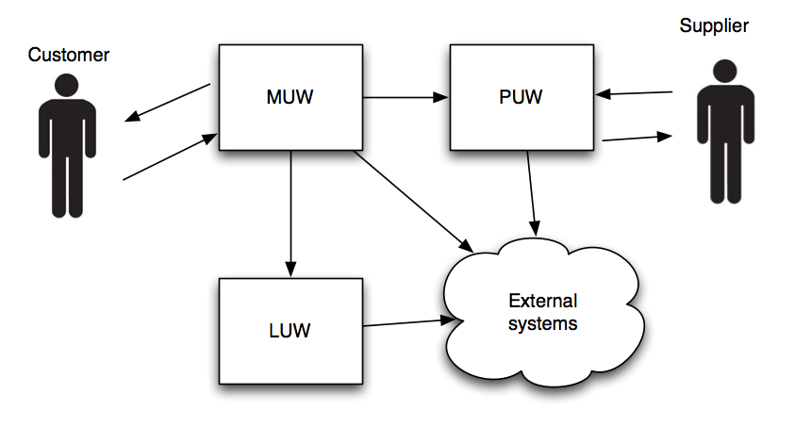

Figure - Overview of the system.

* 1. Stakeholders

The stakeholders for the project are Company 10 who will build and deliver the system, Coira who is the acquirer of the system and Coira’s customers.

* 1. Aim and goal

The aim of the requirements specification is to clearly define what the acquirer wants Company 10 to produce. The goal is to get a clear picture of the overall system.

* 1. Use cases

The use cases are specified from the end users’ point of view. See Appendix A for detailed information.

* 1. Background information

Central Operative & Independent Retailers Acquirer (Coira) is an enterprise with a number of retailers in large parts of the western world. Coira deals in a number of unspecified products and wishes to expand to the rest of the world through a web-based portal, called "the Unlimited Well” (UW). To achieve this, Coira wants to create systems for handling retail, customer purchases and logistics, all of which should utilize existing systems, such as Coiras financial system. Coira has contacted Company 10 to design and produce these systems.

* 1. Definitions

The following abbreviations will be used throughout the report.

|  |  |
| --- | --- |
| **Abbr.** | **Explanation** |
| UW | The Unlimited Well (The whole system) |
| MUW | Mall at the Unlimited Well (The web-portal) |
| PUW | Purchase at the Unlimited Well (Supplier portal) |
| LUW | Logistics at the Unlimited Well (Transportation) |
| GIS | Geographical Information System |
| F | Functional requirement |
| NF | Non-functional requirement. |

The requirements will be prioritized as P0, P1 and P2 where P0 is the highest prioritization and P2 the lowest.

Overview of the system

The Unlimited Well (UW) is to be a web-based portal offering Coira’s products to customers all around the globe. The system consists of the three sub-systems; MUW, PUW and LUW. MUW handles customers, displays products and allows purchases. PUW handles supplies and suppliers. LUW takes care of logistics, customs and transportation of customers’ products.

* 1. Product components

**Mall at the Unlimited Well (MUW)**

Contains the interface towards the customer and the database of available products.

**Purchase at the Unlimited Well (PUW)**

Handles contact with suppliers.

**Logistics at the Unlimited Well (LUW)**

Handles contact with transporters.

* 1. Dependencies with other systems

The following table defines UW’s dependencies with other systems.

|  |  |
| --- | --- |
| **System** | **Dependency** |
| GIS | For geographical information. |
| Customs | To make sure that customs are not a problem. |
| Economy/finance | Coiras’ existing system for handling invoices and similar. |
| Customer Register | Register of existing customers. |

* 1. Included sub-systems

The included sub-systems in the project are:

* MUW
* PUW
* LUW
  1. Delimitations

Due to the time and resource limitations, low-prioritized requirements will not be implemented. Medium-prioritized requirements will be implemented if time permits.

* 1. Design philosophy

Due to time and resource limitations each module should at least be able to work individually.

* 1. General requirements of the whole system
     1. Design requirements

|  |  |  |
| --- | --- | --- |
| **No** | **Requirement** | **Priority** |
| NF1.1 | The system should be internet based and available to different platforms and browsers. | P0 |
| NF1.2 | The system should be easy to understand and interact with. | P1 |
| NF1.3 | The system should be able to run on multiple server architecture to provide portability. | P2 |
| NF1.4 | User integrity should be respected. | P1 |
| NF1.5 | The system should be available at all time. | P1 |
| NF1.6 | The system should be globally accessible. | P0 |
| NF1.7 | The system should provide high security. | P1 |
| NF1.8 | The system should work with a minimum of manual intervention. | P0 |
| NF1.9 | Interfaces between sub-systems should be well defined. | P0 |
| NF1.10 | The system should scale well | P2 |

* + 1. Functional requirements

|  |  |  |
| --- | --- | --- |
| **No** | **Requirement** | **Priority** |
| F1.1 | The system should be accessible through a text-based browser. | P2 |
| F1.2 | The system should be localizable in English, Swedish, Spanish, French, Portuguese and Canton Chinese languages | P0 |
| F1.3 | The system should support mobile platforms. | P2 |
| F1.4 | System should get and utilize information from a GIS company. | P2 |
| F1.5 | The system should make information available for financial systems. | P0 |
| F1.6 | The system should produce necessary documents from suppliers to customers. | P0 |
| F1.7 | Transporters should be able to use the system to update transport status. | P1 |
| F1.8 | System should plan and coordinate transportations. | P2 |
| F1.9 | System should choose and book appropriate transportation upon purchase. | P0 |

Sub-system 1 – MUW

MUW is the shopping mall of the system. This is the interaction point for the end users.

* 1. Description of MUW

MUW handles all interaction with the customer. MUW displays all available products, their details, their price and how long it will take to deliver. MUW also handles the customers orders, displays information and options about orders, such as where they are and if there is any problems, and notifies the customer if there is any hiccups along the way. MUW's graphical interface will provide context-sensitive help at all levels of the interface. At purchase, MUW should find an optimal combination of supplier and transporter. MUW contains the database of available products, their status and suppliers, as well as the customer register. MUW must support several languages and it must be easy to extend the number of languages supported. MUW will also collect statistics about purchases and use these to make predictions about demands and ask PUW to make sure that there is enough supply to satisfy the demand.

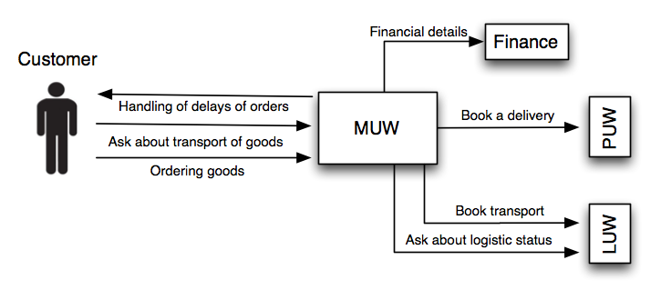

Figure - Detailed view of the MUW system

* 1. Interface requirements

The interface requirements describe what input can be sent to the MUW system, and what output the system will produce.

|  |  |  |
| --- | --- | --- |
| **No** | **Requirement** | **Priority** |
| NF2.1 | Request PUW to acquire a specific item from a specific supplier | P0 |
| NF2.2 | Request LUW to book transportation for the item, given supplier and customer. | P0 |
| NF2.3 | Request transportation status from LUW. | P1 |

* 1. Design requirements

The design requirements describe the non-functional requirements of the MUW system.

|  |  |  |
| --- | --- | --- |
| **No** | **Requirement** | **Priority** |
| NF1.1 | The system should be internet based and available to different platforms and browsers. | P0 |
| NF1.2 | The system should be easy to understand and interact with. | P1 |
| NF1.4 | User integrity should be respected. | P1 |
| NF1.5 | The system should be available at all time. | P1 |
| NF1.6 | The system should be globally accessible. | P0 |
| NF1.7 | The system should provide high security. | P1 |

* 1. Functional requirements

This section describes the PUW’s functional requirements.

|  |  |  |
| --- | --- | --- |
| **No** | **Requirement** | **Priority** |
| F2.1 | Display products and their details. | P0 |
| F2.2 | User should be able to log on to web-portal at any time. | P0 |
| F2.3 | Send information to LUW for any relevant user activity (registration/purchase) | P0 |
| F2.4 | Send information to PUW for any relevant user activity (registration/purchase) | P0 |
| F2.5 | Create sales forecast based upon sales history | P2 |
| F2.6 | Request that PUW has sufficient supplies based on F2.5 | P2 |
| F2.7 | Notify customer on delays | P1 |
| F2.8 | Allow cancellation of orders | P1 |
| F2.9 | Change customer registration details | P1 |
| F2.10 | Provide customer registration | P0 |
| F2.11 | Check transportation status at any time | P1 |
| F2.12 | Remove customer | P1 |
| F2.13 | Check transportation availability | P2 |
| F2.14 | See transportation availability given a specific area on a map (based on F2.13) | P2 |

Sub-system 1 – PUW

PUW is the supplier system. It handles the suppliers and requests quality reviews.

* 1. Description of PUW

PUW is, upon purchase, to contact the chosen supplier and book the products specified. PUW will also keep track of suppliers and update their status in MUW's database. PUW will select suppliers that should undergo a quality review given certain conditions. PUW also has to notify Coira employees if there are not enough suppliers in the system to meet the demand as predicted by MUW, so that new suppliers may be acquired. PUW will also handle delivery notes and send all required data to Coiras’ financial system.

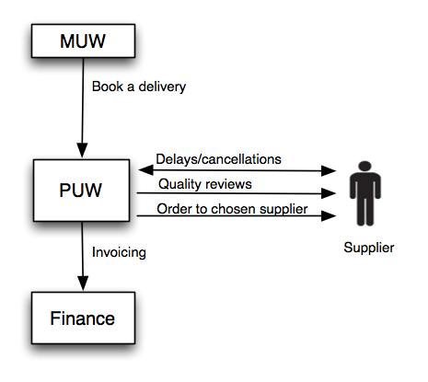

Figure – Detailed view of the PUW system

* 1. Interface requirements

The interface requirements describe what input can be sent to the PUW system, and what output the system will produce.

|  |  |  |
| --- | --- | --- |
| **No** | **Requirement** | **Priority** |
| NF3.1 | Order product form chosen supplier | P0 |
| NF3.2 | Contact financial system with relevant data | P0 |
| NF3.3 | Cancellation of orders | P2 |

* 1. Design requirements

The design requirements describe the non-functional requirements of the PUW system.

|  |  |  |
| --- | --- | --- |
| **No** | **Requirement** | **Priority** |
| NF1.2 | The system should be easy to understand and interact with. | P1 |
| NF1.5 | The system should be available at all time. | P1 |
| NF1.7 | The system should provide high security. | P1 |
| NF1.8 | The system should work with a minimum of manual intervention. | P0 |

* 1. Functional requirements

This section describes the PUW's functional requirements.

|  |  |  |
| --- | --- | --- |
| **No** | **Requirement** | **Priority** |
| F3.1 | Accept orders from MUW | P0 |
| P0 | Place an order with suppliers | P0 |
| F3.3 | Produce delivery notes for all consignments | P0 |
| F3.4 | Provide financial system with data for bookkeeping and invoicing | P0 |
| F3.5 | Provide best supplier given customer location and ordered items | P1 |
| F3.6 | Request supplier quality review from UW staff | P1 |
| F3.7 | Update product database with available products | P0 |
| F3.8 | Provide promotion support for suppliers with good price/time ratio. | P2 |

Sub-system 3 – LUW

LUW is the transportation system. It handles the contact with transportation companies and makes sure hat the products are delivered on time.

* 1. Description of LUW

LUW will be responsible for handling logistics and transportation and keeps track of transporters and their routes. Upon purchase, LUW will book suitable transportation and produce all the needed papers, such as bills of lading and import licenses. LUW is responsible for updating the status of orders and where a particular order is physically. To be able to do this, LUW must accept input from a number of different sources so that the companies that handle the actual transport can update regardless of internal system used. LUW shall utilize a GIS company to compute distances and time consumption. LUW must also make sure that each transport is as profitable as possible with very few, but existing, exceptions. LUW must also allow independent transporters to use the system to plan transports and routes. This includes transports that have nothing to do with Coira. In this case the system is called "Logistics at Transporters" (LaT). In case the system is used this way, the content in the transporters area must be exclusive to that transporter. LUW should notify MUW and Coira personnel in case any hiccups occur.

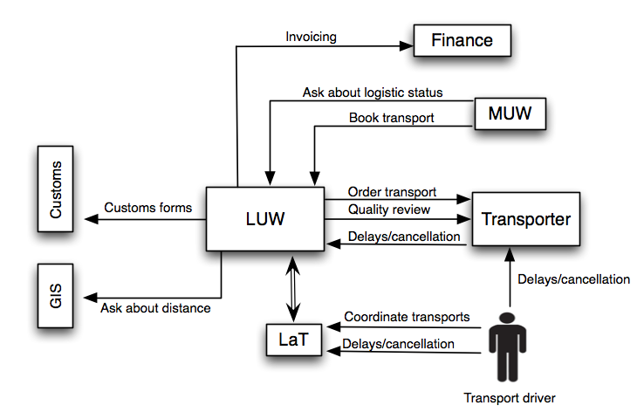

Figure - Detailed view of the LUW system

* 1. Interface requirements

The interface requirements describe what input can be sent to the LUW system, and what output the system will produce.

|  |  |  |
| --- | --- | --- |
| **No** | **Requirement** | **Priority** |
| NF4.1 | Interface to customs for calculation of taxes | P0 |
| NF4.2 | Communicate to GIS for geographical information form supplier to customer | P2 |
| NF4.3 | Get a transport booked for transportation by MUW | P0 |
| NF4.4 | Status updates from transporter | P2 |
| NF4.5 | Provide transportation status to MUW | P2 |
| NF4.6 | Delays and cancellation of orders | P2 |
| NF4.7 | Send the financial system relevant data | P0 |

* 1. Design requirements

The design requirements describe the non-functional requirements of the LUW system.

|  |  |  |
| --- | --- | --- |
| **No** | **Requirement** | **Priority** |
| NF1.2 | The system should be easy to understand and interact with. | P1 |
| NF1.5 | The system should be available at all time. | P1 |
| NF1.7 | The system should provide high security. | P1 |
| NF1.8 | The system should work with a minimum of manual intervention. | P0 |

* 1. Functional requirements

This section describes the LUW's functional requirements.

|  |  |  |
| --- | --- | --- |
| **No** | **Requirement** | **Priority** |
| F4.1 | Find and book an optimal transportation from a supplier to a customer | P0 |
| F4.2 | Receive transportation booking from MUW | P0 |
| F4.3 | Handle cancellations of order/transport | P2 |
| F4.4 | Update order status | P1 |
| F4.5 | Produce required documents; bills of lading | P0 |
| F4.6 | Sends available data to financial system regarding the order | P0 |
| F4.7 | Request transporter quality review from UW staff | P2 |
| F4.8 | Communicate with transporter through LaT | P2 |

Performance requirements

The system will consider the following requirements from a performance perspective.

|  |  |  |
| --- | --- | --- |
| **No** | **Requirement** | **Priority** |
| NF1.2 | The system should be easy to understand and interact with. | P1 |
| NF1.5 | The system should be available at all time. | P1 |
| NF1.10 | The system should scale well | P2 |

Extensibility

The system will provide extensibility by adding language support. The following requirement defines this.

|  |  |  |
| --- | --- | --- |
| **No** | **Requirement** | **Priority** |
| F1.2 | The system should be localizable in English, Swedish, Spanish, French, Portuguese and Canton Chinese languages | P0 |

Reliability

The system should provide high availability and accessibility to users, defined in the following requirements.

|  |  |  |
| --- | --- | --- |
| **No** | **Requirement** | **Priority** |
| NF1.3 | The system should be able to run on multiple server architecture to provide portability. | P2 |
| NF1.5 | The system should be available at all time. | P1 |
| NF1.6 | The system should be globally accessible. | P0 |

Economy

The customer has not provided any economical requirements for the project. Also, all man-hours allocated for the project development are free.

Security

The system must provide high security and be resistant to attacks.

|  |  |  |
| --- | --- | --- |
| **No** | **Requirement** | **Priority** |
| NF1.4 | User integrity should be respected. | P1 |
| NF1.7 | The system should provide high security. | P1 |

Delivery requirements

The system will be delivered as a whole, consisting of three separated modules.

Documentation

The following documents will be delivered to the acquirer.

|  |  |  |  |  |
| --- | --- | --- | --- | --- |
| **Document** | **Language** | **Aim** | **Audience** | **Format** |
| Technical documentation | English | Define all requirements of the system | Technical responsible | PDF |
| User manual | English | Introductory description of the system. | Coira personnel | PDF |
| Installation manual | English | Installation instructions for the system | IT Administrator | PDF |

Education

Company 10 will not provide any education for the system. The system should be self explanatory from the user manuals.

Quality requirements

The system will assure quality from the requirements specified in the sections 6, 8 and 10.

Maintainability

The system will be module based so each module easily can be maintained. Also, the following requirements results in better maintainability:

|  |  |  |
| --- | --- | --- |
| **No** | **Requirement** | **Priority** |
| NF1.8 | The system should work with a minimum of manual intervention. | P0 |
| F1.2 | The system should be localizable in English, Swedish, Spanish, French, Portuguese and Canton Chinese languages | P0 |